July 15th, 2012
Hi
Well, today is Kaia's birthday. Nadine should be getting a present for her on my behalf.
Took swimming a bit easier this past week. Did 2.5 km each day but without any 'training', just ordinary swimming with a bit more breaststroke.
The bimonthly electricity bill arrived the other day. ('Bi' means '2' but bimonthly can mean either 2 times a month or once every 2 months; in this case it is the latter.) It came to $260 or $130 pm (to convert to US$, divide by 8). However, there was nothing to pay due to a government subsidy of $150 pm to every household which began more than a year ago and has been extended for another year. Also, any unused amount is also carried forward. So - courtesy of the government - I turned on the lounge air-con for about 2 ½ hours in evening (and for each evening since); it may not add much to my bill but it does not help the environment. Utilities have turned out to be much cheaper than I had expected. Before moving in, I has estimated about $800 pm for them, but it seems it will be closer to just $50 (not all bills are in so will have to see). Expenditures:
- Electricity: 0 (because of government subsidy)
- Gas: ~$50 pm (first bimonthly bill due this week)
- Water: 0 (due to first 3 cubic metres a month free) (but first bill still not in)
- Internet & telephone: 0 (paid by the owner and included in the “Maintenance fee” all owners pay for the upkeep and security of the estate).
Further, I mentioned some time that I am entitled to government “fruit money” of $1090 pm. Well the amount for the first two months was deposited the other day. During his election campaign, the new CE promised to double the amount. In a letter that arrived confirming the allowance, it includes a note “..... imprisonment, death, will affect the allowance …....... if any of these things happen, you are reminded to report immediately to the …..........”. Interesting - perhaps the government knows something that the rest of us do not know!! In addition, I can now get a special Octopus card that allows travel on public transport for a maximum of just $2 a trip and also entry to some museums, wetland park, etc for the same amount. So, if all this keep going, they will soon be paying me to live here!!
I heard on the radio news the other day that the “Rolling Stones” band is 50 years old. Their kind of music does not appeal to me; it seems to be just a few levels above the most primitive sounds humans can make. I have my doubts that it will be played in another 50 years. This contrasts with the “Beatles” music which does seem to last and is used many times in other arrangements, including those for orchestra, suggesting it will last.
The administration of the new CE is in trouble less than two weeks after taking office. One of the new government secretaries/ministers has had to resign over a renting scam about 25 years ago in which he was claiming rent while a civil servant for which he was not entitled. As I said in an earlier letter, how the media dig up all this stuff, particularly going back nearly 30 years, I don't know. Also, a former Chief Secretary (the #2 in the government hierarchy just below the CE) and the two co-chairmen of one of the biggest property/construction companies (Sun Hung Kai) were charged with corruption by the ICAC.
A interesting snippet from the latest Time magazine “Two years is the average time cut from your life expectancy if you spend more than three hours a day sitting!” How do they work that out? So, if true, be warned!

I am now re-reading “A Brief History of Time” by Stephen Hawking which deals with how the universe began and evolved. I started reading it years ago but gave up as it was too complicated. It was supposed to be written for the general reader but even though I have degrees in science (admittedly rather rusty) I could not understand it. This time, I will finish the book but still without a good understanding. The book is not well written; when/if I understand the subject, I will be able to write a better book. But reading it now came at a good time as the latest Time has an article about the discovered of the so-called “God particle” which should bring scientists a step closer in understanding where everything came from. To discover it, they needed to use a machine, located underground in Geneva, costing about USD10 billion!! (pic). If you are interested, here is the full article (which only subscribers can access):
http://www.time.com/time/subscriber/article/0,33009,2119322,00.html
Gavin - got the pic from Kauai. It does indeed seem to be a very beautiful place. And aren't the beaches in such pristine condition? A pity that people such as me with skin cancer can no longer enjoy them. And talking about that, I go to the hospital on Tuesday (first time for well over a year) as a follow-up to the dermatology biopsies I had a few weeks ago.
That's about it
Cheers
PS: I included the letter (below) from the same date five years ago.

July 15th, 2007
Hi
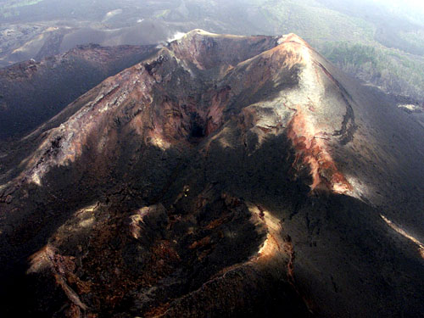

I forgot to mention in last week’s letter of an accident in the (Democratic Republic of) Congo. A Hong Kong tour party, with guides, had climbed to the top of a 3500-metre high active volcano. While taking photographs, a woman fell more than 200 metres onto a ledge into the crater of the volcano. After a day, UN troops arrived and tried to reach her but by then she had died.
Last Sunday, a small Cessna single-engine aircraft made an emergency landing on the Plover Cove Reservoir dam, after it suffered engine problems. Both people on board the escaped injury, and the plane itself was not damaged. The plane was on flying practice over the New Territories when the engine trouble occurred. This is the second time that a plane has landed on this dam.
On Tuesday, I received my new drivers’ license by post from the Transport Department. Very efficient indeed! I remember 10 years ago having to fill out forms and spend a long time in queues in the Shatin office to get the (10-year) licence. This time it could be done on the Internet but only if you have a digital (identity) certificate, which I do not have. Then out of the blue a letter arrived from the department with an application form already filled out for me to sign and return with a cheque. This I did and the new licence arrived about a week later. I am very impressed with the service. However, I only got a licence for 3 years and not 10 years because of my age. Have to have a health check-up before getting the next licence.
Last Wednesday morning, the hotel did a quarterly cleaning of the suite. Therefore, I went to the CU clinic at that time to get more asthma medicine. Then I called in at the Faculty of Education and had a chat with some people I saw there.
Last Thursday, I was a bit tired but started exercise again, doing just 15 min skipping followed by a 1.2 km swim (in 33/34⁰C water). A little more the following day.
Over the past few weeks, HK has been having very fine weather and the air on many days has been very clear. This is because (relatively) clean air from the South has been blowing across HK. But things will soon return to normal with a northerly wind bringing air pollution from China. Very hot too. Yesterday, temperatures in Sheung Shui reached 36⁰C.
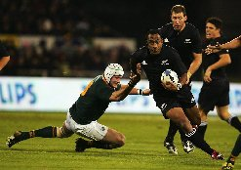
Yesterday, I watched on TV the All Blacks struggle past a SA second-string side to eventually win 33 – 6. All the interesting action was in the last 15 minutes, with the ABs scoring 3 converted tries (21 points) all in the last 11 minutes. The final Tri-nations test is next Saturday between NZ and Australia.
I will not see next week’s test, as I will be in Singapore. I go down on Thursday for just over a week for the re-launch of the revised lower secondary science books. I will give a brief 30-minute talk at the launch (actually, I will give it 3 times to different groups). Later I will conduct a half-day workshop on teaching science.
That seems to be it for now. Will write again in two weeks.
Cheers

